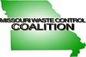

CERTIFICATE OF ATTENDANCE
CLE

I hereby certify that ____________________________________ attended the Missouri Waste Control Coalition Environmental Conference at Margaritaville Lake Resort in Osage Beach, Missouri on July 12 – July 13, 2021.

This conference qualifies for 12.6 hours of continuing legal education in the state of Missouri.
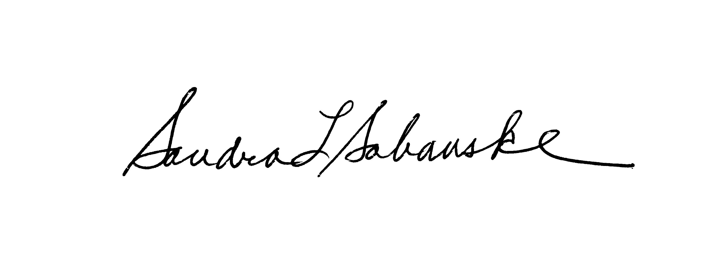
Sandra L. Sabanske
Executive Director

Dated: July 13, 2021

