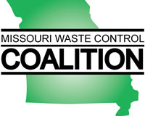

CERTIFICATE OF ATTENDANCE

I hereby certify that ____________________________________ attended the Missouri Waste Control Coalition seminar entitled:
Characterization and Remediation of Fractured Rock:
an ITRC Training Program
which occurred on May 15, 2018 at the Kauffman Conference Center in Kansas City, Missouri.

This seminar offered 7 hours of continuing education credit.
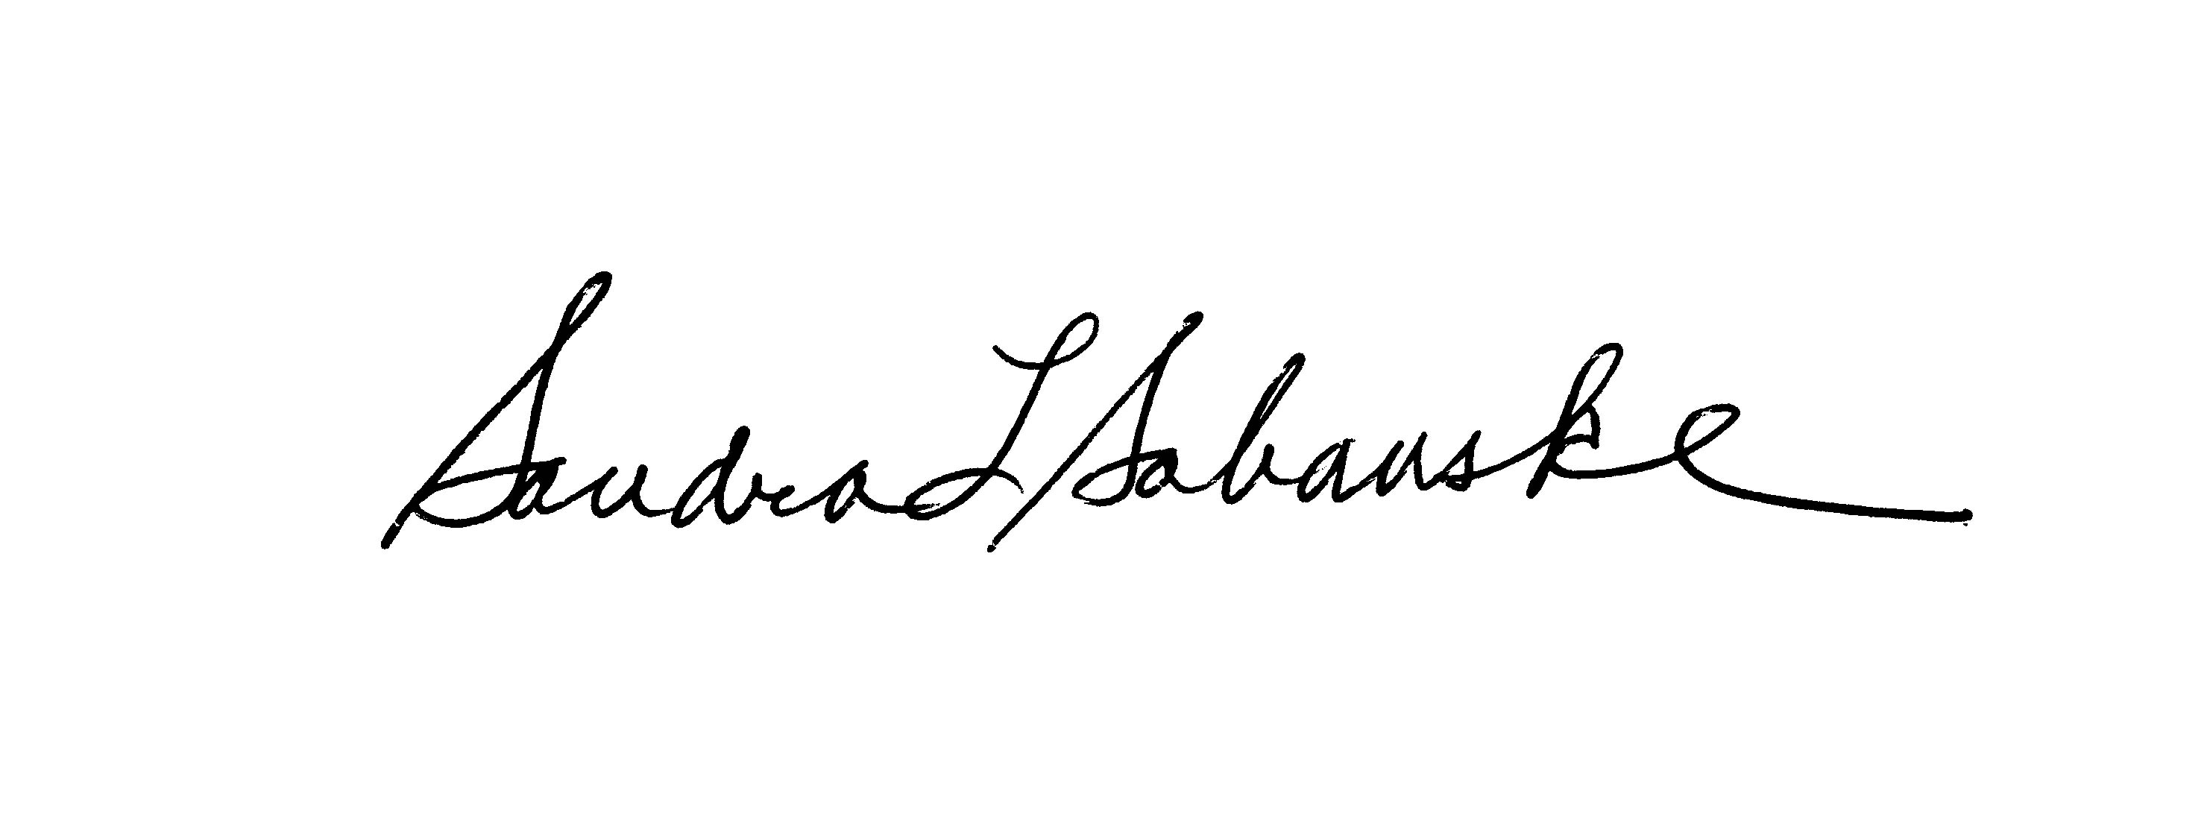
Sandra L. Sabanske
Executive Director

Dated: May 15, 2018

