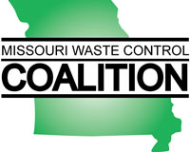

CERTIFICATE OF ATTENDANCE

I hereby certify that ____________________________________ attended the Missouri Waste Control Coalition seminar entitled:
Light Non-Aqueous Phase Liquids (LNAPL) Update:
an ITRC Training Program
which occurred on October 12, 2018 at The Engineers Club in St. Louis, Missouri.

This seminar offered 7 hours of continuing education credit.
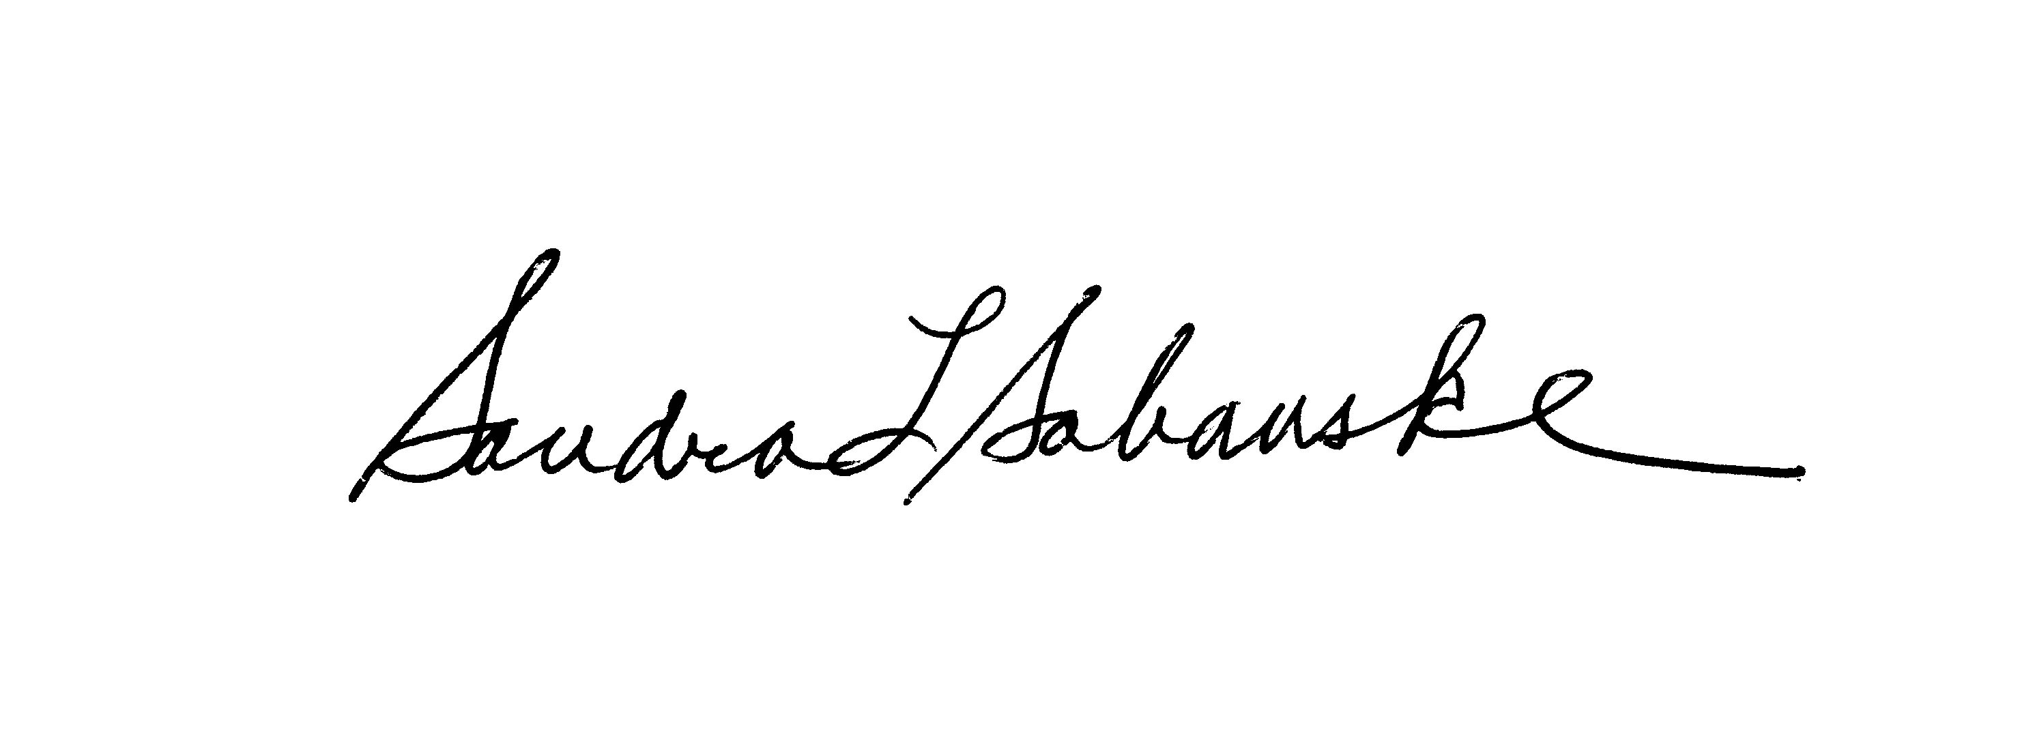
Sandra L. Sabanske
Executive Director

Dated: October 12, 2018

