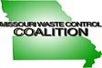

CERTIFICATE OF ATTENDANCE

I hereby certify that ____________________________________ attended the Missouri Waste Control Coalition Environmental Conference at Margaritaville Lake Resort in Osage Beach, Missouri on July 11 – July 12, 2022.

This conference provided for a total of 10 hours of continuing education.
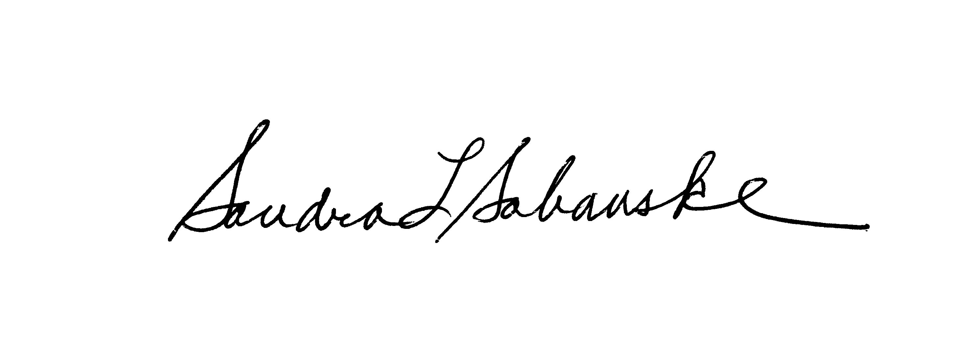
Sandra L. Sabanske
Executive Director

Dated: July 12, 2022

